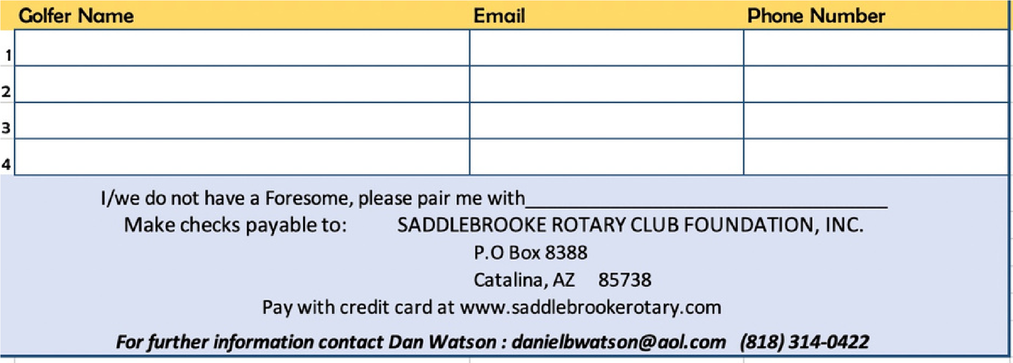

ROTARY

CHARITY

GOLF

TOURNAMENT

**benefiting YOUTH PROGRAMS**

**and SCHOLARSHIPS**

MOUNTAINVIEW COUNTRY CLUB

Shotgun 1 pm

Four person Best Ball Scramble

**Golfer Contribution $160**

**Foursome $600**

Register & Pay at

saddlebrookerotary.com

**Includes:**

**Golf, Driving**

**Range**

**On Course Lunch**

**` Buffet Dinner**

**following golf**

Special Hole-In-One Awards

on every Par 3

Plus on course contests for

Ladies and Men

Tees based on Age and Gender

**MONDAY**

**APRIL 21, 2025**